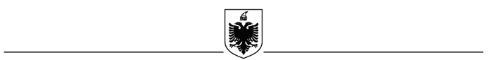
REPUBLIC OF ALBANIA
MINISTRY OF DEFENSE
NATIONAL CIVIL PROTECTION AGENCY

No. ________ prot. Tirana, ____.____.2022

CANCELLATION NOTIFICATION IN THE PUBLIC NOTICE BULLETIN

- Name and address of the contracting authority

Name NATIONAL CIVIL PROTECTION AGENCY
Address : Rruga e Dibrës, Garnizoni “Skënderbej” Tirana
Tel / Fax + 355 4 2226601/6602 / +3554 22283 25
E-mail procurement.publik@akmc.gov.al
Website https://www.mod.gov.al

Type of procedures: (Competitive dialogue - Procurement in the field of Security and Defense)
3. Reference Number: Order of Procurement no. 67, dated 07.04.2022.

4. Object of the contracts: Realization of the territory monitoring project with advanced technology, for a period of 3 (three) years.

5. Limit fund: / Expected value of the contract: 671.760,000 (six hundred seventy one thousand seven hundred sixty) ALL without VAT
The value of the limit fund in the main international currencies according to the exchange rate of the Bank of Albania is:
- 5.522.071 Euro without VAT
- 6.000.000 USD without VAT
The official exchange rate according to the Bank of Albania is
- 1 Euro – 121.65 ALL
- 1 USD – 111.96 ALL

6. Reasons for Cancellation:

Based on Law no. 36/2020, "On Security and Defence Procurement", Article 36, point 1
c), because none of the bids is given for the criteria of trademarks in their documents.

7. Additional information

Date of notification: 20.06.2022.

CONTRACTING AUTHORITY TITLE

HAKI ÇAKO

